1. Connect your machine with the Luban via the USB cable.
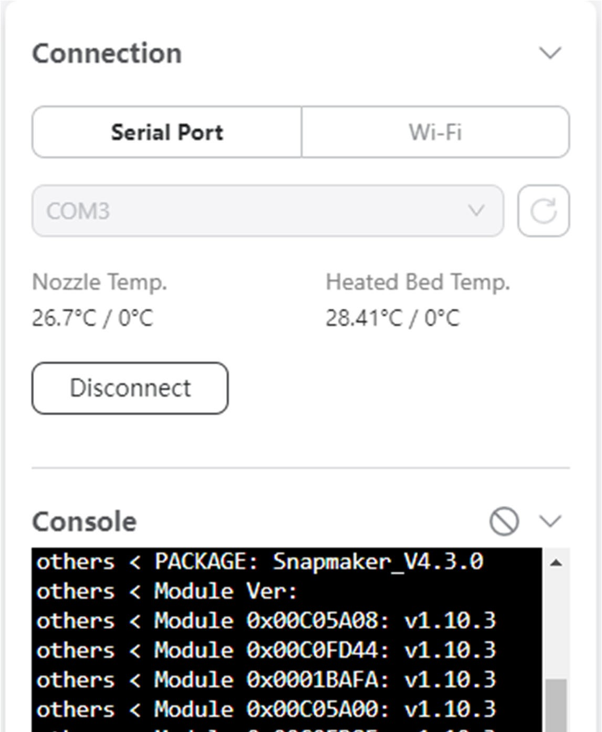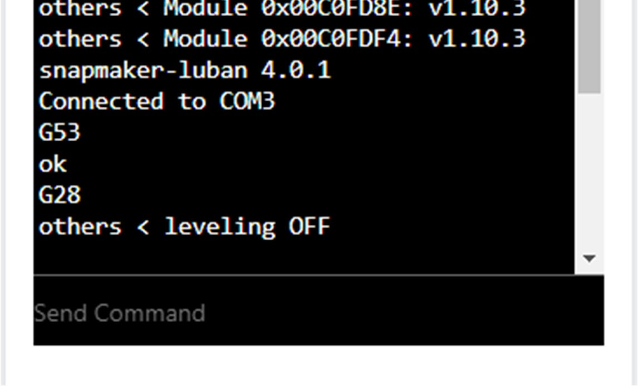

TYPE HERE G1029 P11
- Type in G1029 P3 in the console.
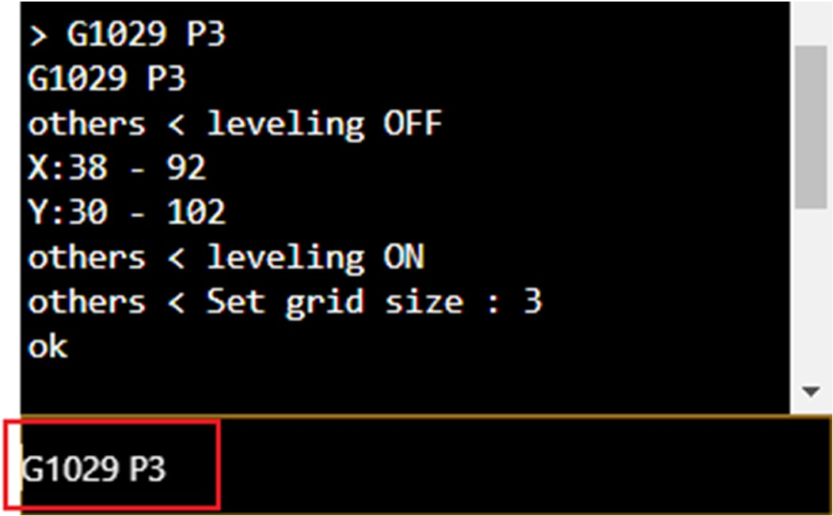
Type in G1029 A to start the auto-leveling. BY now it should keep the temp itself but always heat the bed to 70 or 80 degrees celsius
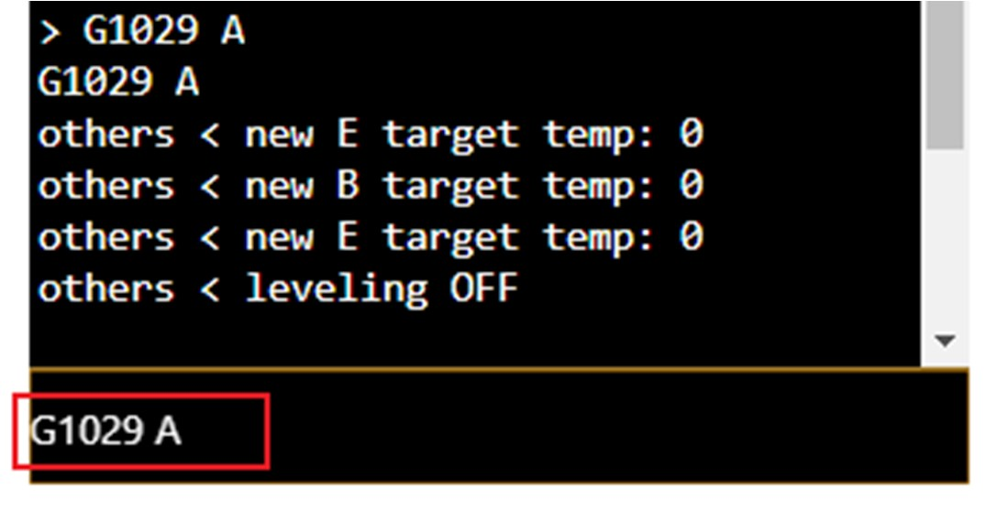

- Adjust the last point in Luban. Be aware of the travel distance.
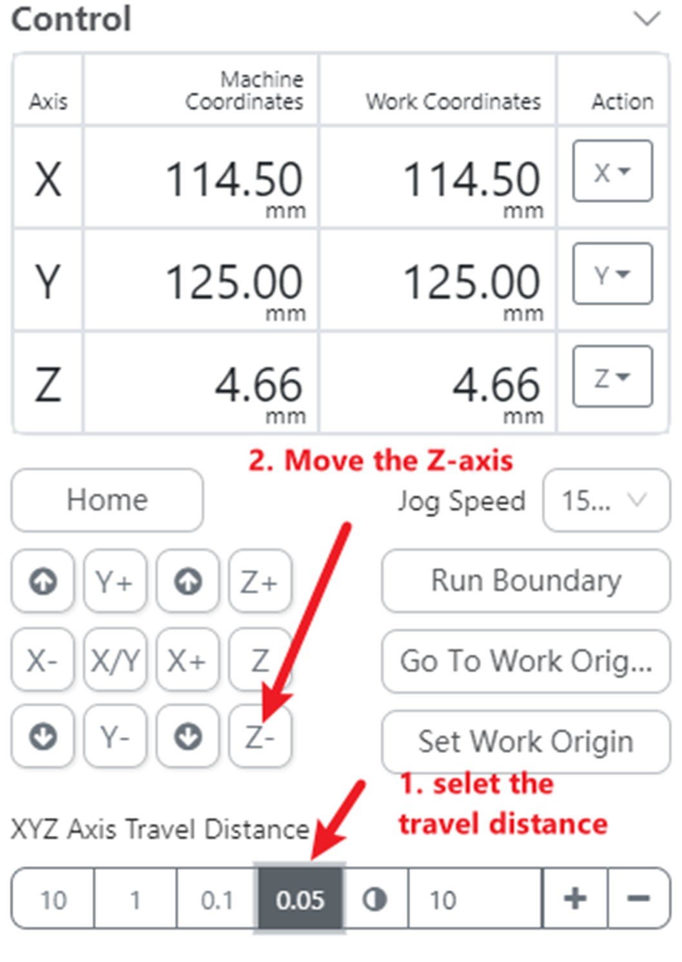
- Type in G1029 S to save the calibration configures.
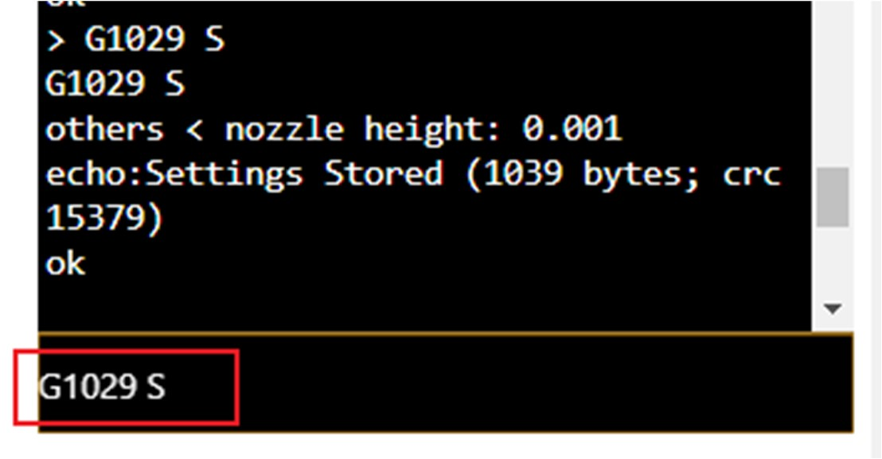

- Type in M500 to save the configurations.
