Volcano hotted for the J1

Based on the idea of Chris Harrison, I made some effort to create the Super Volcano for the J1.
The idea is based on using Volcano spacers and the high-flow nozzle for the X1. But basically, every nozzle could be used, so do not throw yours away just yet.
I knew Jade and her amazing team would come up with a much better solution but I have always been impatient. I recommend you wait for Jade’s team’s answer, but if you may have the parts at hand and want to give it a go…

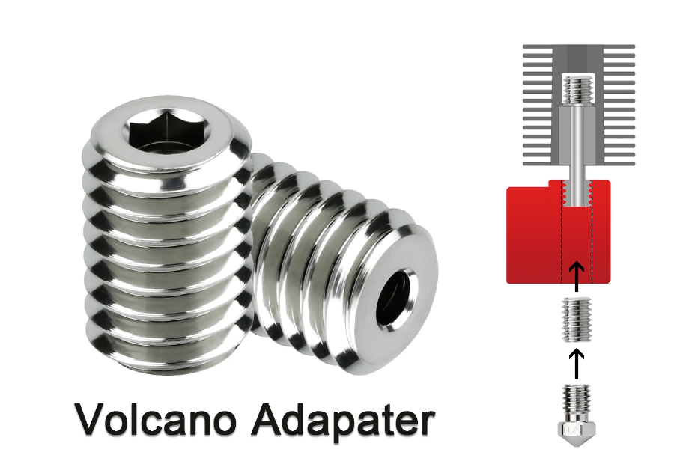
It all starts with the Volcano spacer. You can change the heatsink and use a shortened Volcano spacer there too but you also can use the original heatsink. It is a bit rough but as you get more heat with the Volcano, it may well work well.

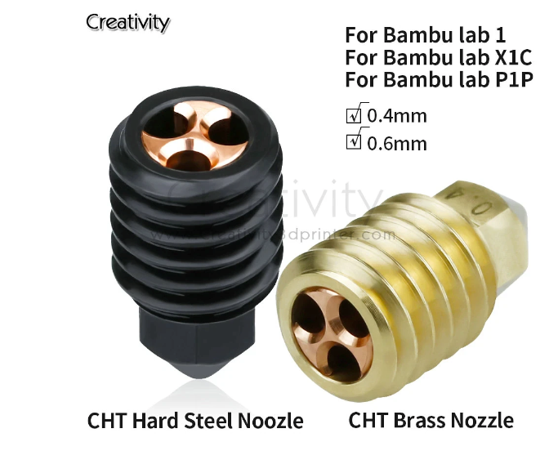
I also used a special nozzle, just because I can.
The X1 high flow interested me

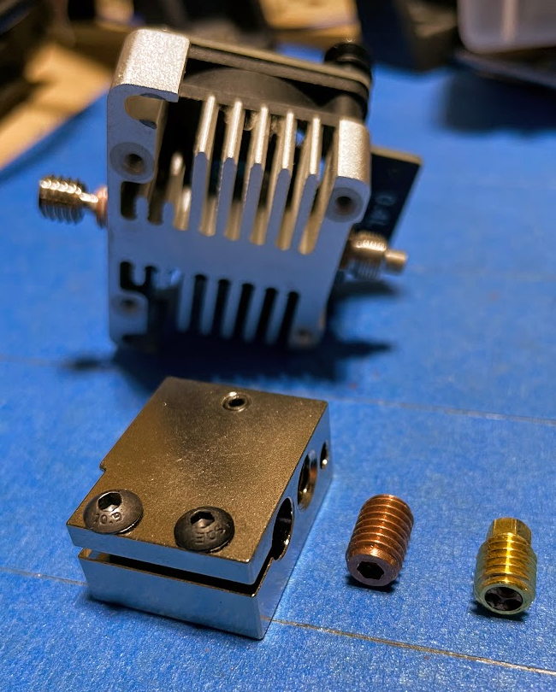
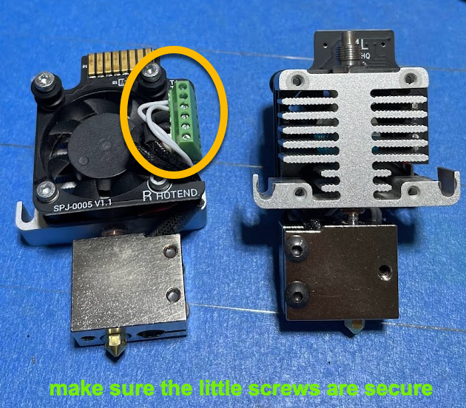
All up it is an easy upgrade and I am sure the extra flow will be beneficial.

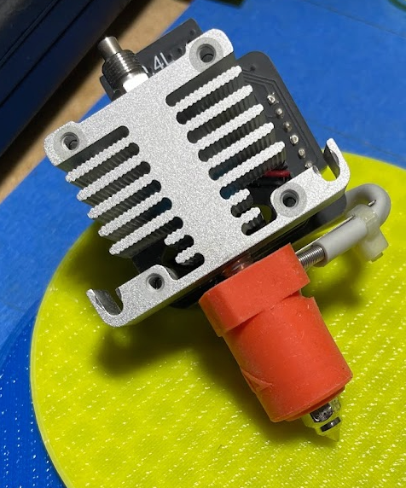

I made one with the ceramic heater. But I had to change
the firmware (I actually asked a friend to do it as I am too silly).

As the bed heats up way slower than the nozzle anyway, I could not see much sense in it. There will certainly be enough
flow in this unit.

